Optimal Routing of Vehicles by Geospatial
Clusterization Method

A. B. Filimonov
MIREA – Russian Technological University
Moscow, Russia
filimon_ab@mail.ru
N. B. Filimonov
Lomonosov Moscow State University
Moscow, Russia
nbfilimonov@mail.ru

Abstract–– The article considers one of the urgent and key problems of the transport industry related to the planning of routes for transport vehicles (TV). For many application this problem can be described and formalized as the traveling salesman problem (TSP), which consists in finding the optimal route for a traveling salesman to visit all the specified cities once and then return to the source city. In general, when planning routes, one has to deal with the multiple problem of a traveling salesman. Multiple Traveling Salesman Problem (MTSP), which allows more than one traveling salesman and more than one depot - their base location, where routes begin and end. TSP, as a combinatorial optimization problem, belongs to the class of NP-hard problems and its solution by the method of complete enumeration is almost impossible for the case of 20 cities. One of the heuristic methods for its solving, which is described in this article, is based on geospatial clusterization of the initial set of cities. First we consider MTSP with one depot, for which a two-index mathematical formalization is given and which, using the Miller-Tucker-Zemlin method, is reduced to the problem of integer linear programming. Then more complex problem is considered - MTSP with several depots. A two-stage CFRS ("Cluster First - Route Second") method for solving this problem is discussed, which allows reducing it to TSP family with a single depot. At the first stage, geospatial clusterization of cities is carried out and clusterization using the K-means method is used. At the second stage a single depot with vehicles designed to serve this cluster is selected for each cluster and routes to by bypass all cities in this cluster are built. As an example illustrating the effectiveness of the proposed solutions a numerical example of aviation logistics is considered - flight routing of multiple transport UAV with several depots based on them.
Keywords–– transport vehicles, route planning, multiple traveling salesman problem (TSP), variants with one or more depots, integer linear programming, cluster method for solving TSP, geospatial clustering by K-means method, numerical example of aviation logistics.

Introduction
The current problem of the recent transport industry is con-nected by the transport routing and consists in the routes plan-ning of transport vehicles (TV) with minimization of transport costs [1, 2]. Here TV is a technical system fulfilling the functions of the objects transportation (the people and/or traffic) for long distances from one place to the other, and also we may distin-guish the land (car and rail), the water (river and sea)and the air TV, depending on the environment of movement.
Transport costs are total input for the TV transportation in terms of the expansion, duration or the cost of the route. The problem of the TV routing attracts wide attention of the investi-gators by its complexity and practical level in the different sphe-res of the human activity also more than half a century (the transport logistics, security and fire monitoring, search and res-cue missions, ecological and agricultural observation, air patrol and so on). In the current market conditions the transport logistics involved with the questions of planning and control by the flows of the commodity-material values (raw material, mate-rials, ready production and so forth) and above all transportation from supplies and consumers plays more and more important part in connection with the development of the production sphe-res marketing and consumption [3]. The increased attention to issues of the production’s transportation is because that by dif-ferent estimates from 30% to 50% of all inputs for transport lo-gistics is connected by the transportation costs.
Vehicle routing problem (VRP) being under consideration in the article is the modification and generalization of the famous classical travelling salesman problem (TSP) [4, 5]: for set iden-tical TV, located in one or several depots it is required to define the optimal (with minimum transport costs) set of detour routes with single visit of many geographically scattered among the points of the route with compulsory return to depot, that is the point of TV basing, where their transport routes begin and finish.
VRP attracts the wide attention of the investigators also in the order of a century. In this case the first papers, dedicated to the given class of the problems belong to standard TSP, which du-ring the period of its beginning it was customary to refer to the mathematical puzzles (on the strength of the astonishing simp-licity of its interesting posing).Among the most famous puzzles it should be pointed out the game “Round-the-world” by W.R. Ha-milton, 1859y., related to finding a workaround path (without loops) of set tops of dodecahedron (graph with 20 knots). Here the vertices of the graph symbolize cities, and the edges of the graph symbolize roads, connecting them..The first TSP formu-lation as the mathematical problem (so called “messenger’s prob-lem”), which was published in 1930y, belongs to K. Menger. But it is generally agreed that VRP as the classical problem of rou-ting of the only TV [6] for refueling gasoline at gas stations was first formulated and solved by G.B. Dantzig and G.H. Rumser in 1959y. Some years later G. Clarke and J.W. Wright have inclu-ded several TV [7] in the given problem formulation. The actual conditions and restrictions encountered in practice have defined the wide set of variants for VRP formulation [8, 9].
The mathematical formulation is suggested in the papers of the authors [10−15] and also the methods and algorithms of VRP solution, connected by the problems of group patrolling the nar-rowly stretched large territory of the unmanned aerial vehicles (UAV). Here the problem of planning optimal routes of flying over patrol areas by several drones based in several depots is considered. Here the effect of reducing transportation costs du-ring routing is developed very clearly on the large territories. In this report, developed the authors’ papers specified above, this VRP with optimal planning ring routes of variety of TV is con-sidered. The formalized formulation of the given problem as mu-ltiple traveling salesman problem (MTSP) [16] is presented. Se-veral traveling salesmen (commercial agents) for bypass a given set of cities with one time their visit is allowed here. The cluster two-stage method for solving the given MTSP is described. It ensures that it is reduced to a number of MTSP with one depot. As an illustration the suggested solutions, the numerical example of the aviation logistics is given- it is the statement and solution of the problem of optimal routing UAS group in the MATLAB environment.

Classic vrp solving method with one depot
Suppose that all available TV be of the same type and they are serviced by one depot. The route of every TV, named as a tour, starts and ends at this depot moreover one TV is assigned only one tour. The criterion for optimal route is minimum trans-portation costs indicator that is the activities, cost or length of the tour.
Let us consider a meaningful formulation of the VRP problem with one depot, formalized as MTSP. Meaningful VRP sta-tement with one depot, formalized as MTSP, consists of the following: there are cities, one of which is the location of the depot and traveling sales-men are based in it.Their goal is to drive through all the cities. The cost of the removal between the cities is set. MTSP consists in the finding a tour for every traveling salesman, complying with the fol-lowing conditions:
- all traveling salesman routes should be circular, that is with the beginning (start) and the end in the depot;
- every city is visited only once and only by one traveling salesman;
- the general cost of tours is minimal.
Let us reduce the mathematical formalization of the given problem. The complete graph is given, where is a lot of knots (tops), and is a lot of edges. The graph knots present the cities, and its edges present the routs of the communication between them, and also the knot corresponds to depot, where the traveling salesman routes start and end. The costs matrix is set , where is the cost of the route , which can be treated as the time, expenditures or the distance.
The asymmetry MTSP is modeled by the directed graph, and the symmetry MTSP is modeled by the undirected graph. The symmetry MTSP is called metric if relative to the lengths of the edges the triangle inequality is fulfilled:
We believe, that the considered problem of the optimal TV routing is the symmetric metric MTSP. As the required unknown variables the elements of the movement matrix protrude , where is binary variable, connected to every edge , receiving the value 1, if the edge belongs to the optimal route and value 0 otherwise. Further is subset , which contains all the knots of graph except depot.
The mathematical model for the considered symmetric metric MTSP can be represented by the following:
(1)
; (2)
; (3)
(4)
(5)
. (6)
Thus we have two-index formalization of the VRP under consideration with one depot as MTSP.
Restrictions to degrees of the graph vertices (2) and (3) re-quire so that one edge exactly fits into the vertex and exits from the vertex connected by every city, which is not depot. The re-strictions (4) and (5) guarantee that exactly traveling sales-men leave depot and return back to the depot. It is significant that the accepted restrictions assume the presence of sub-routes (substructures), irreversible the full cycle and impenetrable through the depot. To exclude the effect of the origin such sub-routes permit the conditions in term of the inequalities, formu-lated by G.B. Dantzig, D.R. Fulkerson and S.M. Johnson [17]. The quantity of the additional inequalities providing the elimi-nating sub-routes is equal to .
С.E. Miller, A.W. Tucker and R.A. Zemlin proposed the alte-rnative conditions for eliminating sub-routes [18] (so called MTZ algorithm) by means of the introduction new variables defining the order of visiting cities, requiring only of the suplementary inequalities:
Here is the additional integer variable, representing the quan-tity of the knots (the cities), which traveling salesman not visi-ted yet, and is maximum quantity of the knots (the cities), which can visit every traveling salesman. We may assume, that . As a result, MTSP with one depot is reduced to the linear integer programming problem and to solve it the special algorithms are existed in particular the Gomori algorithm

Metahaeuristics as “gold standard” for MTSP solutions
Solving MTSP due to the theoretical and practical signifi-cance attracts the attention of the world scientific community to the search for effective methods of its solution for more than half a centure. The first approaches to MTSP solution supposed in 1960-1980yy, composed the group of the classical methods, which included the main approaches to the exact and approxi-mate solution for the traveling salesman problems of not small dimension (until 25-30 cities). Since the mid-1990s the researches of the given problems focused on the different metaheuristic methods based on the different ways of simplifying the problem solution. They have not strong basis, do not guarantee accuracy and global optimality, but they give the acceptable problem solution in a reasonable amount of time. These methods permit to get the admissible MTSP solution a high-dimentional (reaching 1 000 000 cities) for which the amount of solution search space approaching by an order of magnitude the number of atoms in the observable universe. Here we may note that the MTSP complexity with the number of cities exceeding only is beyond so called “Bremermann limit”: the number of options for search the problem solution has the form 93-digit number and it will be needed for processing more than bit information, that it takes time some milliards years.
Metaheuristics is “the gold standard” for search of MTSP solutions. As a result, for the given class of the problems the number of metaheuristic algorithms was developed and researched [19, 20] and first of all the following bioinspired (imitating processes in the natural environment and in the behavior of some animal species and some types of plants) algorithms: Tabu Se-arch (TS), Simulated Annealing (SA), Fireworks Algorithm (FWA), Evolutionary Algorithms (EA), Genetic Algorithms (GA), Bacterial Foraging Algorithms (BFOA), Particles Swarm Optimization (PSO), Ant Colony Optimization (ACO).
A lot of papers, dedicated to metaheuristics, created uncertainty in choosing the best algorithms having the reliability, co-rectness, stabilitty and simplicity. But we can state, that the most popularity for solvinmg of complex optimization problems, the genetic algorithms (GA) have acquired.They are provided for many programmed products including the Global Optimization Toolbox of MATLAB system. Today GA algorithm became “favourite” of MTSP solving as with the only depot, so with se-veral depot [21, 22]. In this case, in parallel with the direct use GA for MTSP solving, the approach based on its reductionto the problem of the integer linear programming with the consequent solving of the last problem by GA method (see f.e.[23] gain the more popularitty.

Two-stage cluster method for solving VRP with multiple depots
Multiple Depot Vehicle Routing Problem (MDVRP) was set at first by G.Laporte, Y.Nobert and G.Arpin in the paper [24].The availability of several depots significantly complicates the corresponding MTSP. One of the most effective approaches for MTSP solution is based on the applicetion of the metho-dology of the space clusterization of all cities, which plan to visit the traveling salesmen.
The clusterization (the cluster) is the process of the dividing (decomposition) of set homogeneous (uniform) objects into no-noverlapping subsets named the clusters based on the degree of their “similarity”. In doing so, in metric space the degree of the “similarity” of every pair of the objects is measured by “dis-tance” between them using the different metrics. The choice of these metrics essentially affects the quality of the clusterization. Along with the power-law, manhattan, chebyshev and mahalano-bisky distances, the Euclidean distance is the most ordinary. It permits to find the hyperspherical accumulation of the clusteri-zation objects.
At present time there are many methods of the clusterization. According to multiple reviews (see, f.e.[25], one of the most popular and sought-after clasterization methods is K-means method [26] because of the symplicyty, obviousness and speed of implementation. The idea of the present method was proposed in the papers by S.P. Loyd and H. Steinhaus in the 50s indepen-dently and has been developed in the papers by E.W. Forgy, H.P. Fridman and J. Rubin, J. MacQueen) in the 1960s.
For MTSP with several depot the clustering two-stage approach [27, 28] has become widespread.The first stage consists in the clusterization of the cities, permitting to consider every re-ceived cluster as the independent territorial unit with its single depot and the traveling salesman, ascribed to it, serving the given cluster. The second stage consists in the routing the traveling salesmen’s route for every received cluster at the first stage. In turn two-stage approach is subdivided into two following me-thods, diametrically opposite:
- the method “Cluster First - Route Second” (CFRS) sug-ges-ted in the papers by B.E. Gillet, L.R. Miller [29] and L.D. Bodin [30] and has been used in a number of publications (see, f.e.[31];
- the method “Route First - Cluster Second” (RFCS) offered by J.E. Beasley [32] and has been used in a number of papers (see, f.e. [33].
The methods CRFS and RFCS are based respectively on the principles of “first clusterization and then routing”and “first rou-ting and then clusterization”. At the same time the CFRS me-thod provides more quality MTSP solving in spite of more com-plex calculations in comparison with the RFCS method, which is rarely used. It should be noted that in a number of papers (see, for example, [34]), in the CFRS method for solving MTSP, along with two stages (clusterization and routing), it is proposed to pro-vide for a third stage related to the improvement of routes obtained in each cluster at the second stage. In the literature, the TSP, which uses the idea of destination clustering, is called a cluster traveling salesman problem (CTSP), and was at first posed in [35].

Reducing mtsp with several depots to MTSP with one depot
In the initial conditions of the cluster MTSP with several de-pots the parameters and have, respectively, the total num-ber of cities and the traveling salesmen, and is the total num-ber of depots.
The traveling salesmen routes are described by full graph , where - is multitle knots (tops), repre-senting the destination route, and - is multiple edges, repre-senting the communication between points. The cost matrix is set, where ,
Let multiple cities is devided into clusters:
, (7)
so that
(8)
where every cluster includes one depot and traveling salesmen routes, based on in this depot. Then the initial MTSP with de-pot naturally is devided into MTSP with one depot. Geospatial clustering of destination (7), (8) permits to fulfill their grouping, starting from the reasons of their territorial proximity.
Let us denote by the sub-graph of graph , generated by multiple tops . .Let us select in the cost matrix sub-matrix, corresponding to multiple tops : , where . For every sub-graph based on the cost matrix we can solve TSP with one depot. The acceptable solutions to this problem are described with movement matrix , where .
Let us assume, that depot and is defined for each cluster. . Let us introduce the notations: is the number of points in cluster; , is the number of TV, based on the depot . Evidently, the following relations must be realized:
, .
Let us formalize mathematically the problem of the optimal routing TV movement in cluster in the form of the following extreme problem:
(9)
; (10)
; (11)
(12)
(13)
(14)
moreover, here to eliminate sub-routes, they should be complemented with conditions by Miller-Tucker-Zemlin:
(15)
There are different variations of MTSP statement and solution in the kind of (9)−(15) using the conception of geospatial clustering. One of these possible variants the following iterated algorithmic scheme is represented:
1. Lot of cities is crashing into clusters (7), (8).
2. In each cluster the nearest to its center city is located, where the depot, serving the given cluster is posted.
3. Starting from cluster size and the number of the cities, incoming in it, the number of traveling salesman is set. which is intended for servicing this cluster.
4, For each cluster the problem of the integer programming (9)−(15) has been solved.
The given MTSP is relative to class of CTSP. Its solution is ambiguous and in many ways is determined by choice of the clustering method. Here the utilization of the base method of K-means is too effective. Its iterated algorithm splits the original set of the objects (cities) for a predefined fixed number of clusters by means of minimization of total deviation of the objects in clusters from their centers. It should be noted that the algorithm of K-means method is efficient and it is converges, but it is sensitive to initial conditions and outliers, which can distort both the mean and split quality.
For clustering of geo-distributed data besides K-means algorithm and the other algorithms could be used. In particular, the algorithms of hierarchical clustering are of interest, among of which it should be noted, for example, method BIRCH (Balanced Iterative Reducing and Clustering Using Hierarchies) [36].

An example of transport drones routing
The main trend of the development of the world transport system of recent years is the sharp increase in numbers of TV, and also the emergence of new their species, among which the key location occupy today the unmanned TV, including the unmanned aerial vehicles (UAV, drones). Today one of trend directions of drones using is transport and logistics sphere and first of all it is postal, courier and commercial delivery services [37, 38]. The efficiency of the given application of drones is agreed upon their smallness, maneuverability, low cost and easy controllability. The researchers from Oxford predict that in the very near future robots will take in logistics up to 80% of jobs and by 2030-2040yy the unmanned truck drones will pick up cargo from “clever” warehouses, fully automated and to supply them to the unloading hubs. From this place they will be able to carve a path to the addresses with the help of the flying drones-couriers. Using drones, the campaigns will not only be able to reduce the most part of costs, but to extend your delivery range.
As a model example, let us consider the following problem of the aviation logistics: there are 26 delivery points with three depots, to each of which 2, 4 and 4 drones are assigned respectively. The coordinates (x, y) of all 26 points with letter designations (a, b, c, …, z) are presented in the Table 1. Their mutual location on the territory in a unified coordinate system is shown in Fig. 1.
Euclidean cluster TSP is considered. Here in the capacity of metric the Euclidean distance is accepted. The solution of the problem was fulfilled in the programming environment MAT-LAB. For clustering by K-means method the K-means function was used. The solution of the problem of integer programming was fulfilled with the help of intlinprog function. As a result three clusters have been formed, where three depots , serving ten drones have been allocated. Fig. 2 illustrates the splitting the set of delivery points into clusters. Here the objects of the clustering are marked with three types of markers. They are: the circle, triangle and square, and the centers of the clusters are marked with a cross. To designate three depots the markers larger size with fill are used.
As a result, we have the following distribution of delivery points and drones by clusters:
- the first cluster: i, k, l, q (depot), t, γ; ;
- the second cluster: a, b, c, d, e, f (depot), j, g, h, m; ;
- the third cluster: n, o, p, r, s, u (depot), v, w, ϕ, ψ; .
In Fig. 3 drone flight routes of delivery points are presented.

- Coordinates of the destinations
 | x | y |  |  | x | y |  |  | x | y
a | 287 | 285 |  | j | 227 | 204 |  | s | 204 | 83
b | 289 | 247 |  | k | 38 | 197 |  | t | 84 | 83
c | 275 | 239 |  | l | 11 | 194 |  | u | 238 | 56
d | 127 | 230 |  | M | 288 | 147 |  | v | 274 | 51
e | 280 | 226 |  | N | 197 | 134 |  | w | 287 | 29
f | 244 | 223 |  | O | 240 | 132 |  | γ | 164 | 14
g | 255 | 213 |  | P | 272 | 118 |  | ϕ | 146 | 10
h | 190 | 212 |  | Q | 43 | 114 |  | ψ | 29 | 10
i | 47 | 208 |  | R | 291 | 95

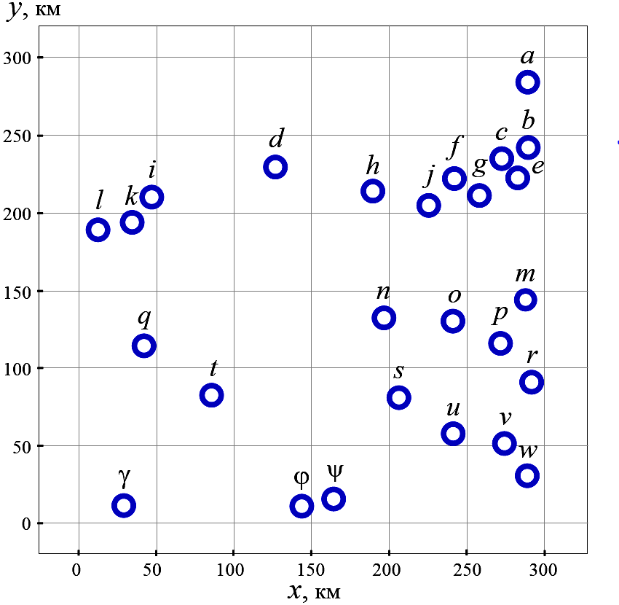
- The relative position of the destinations
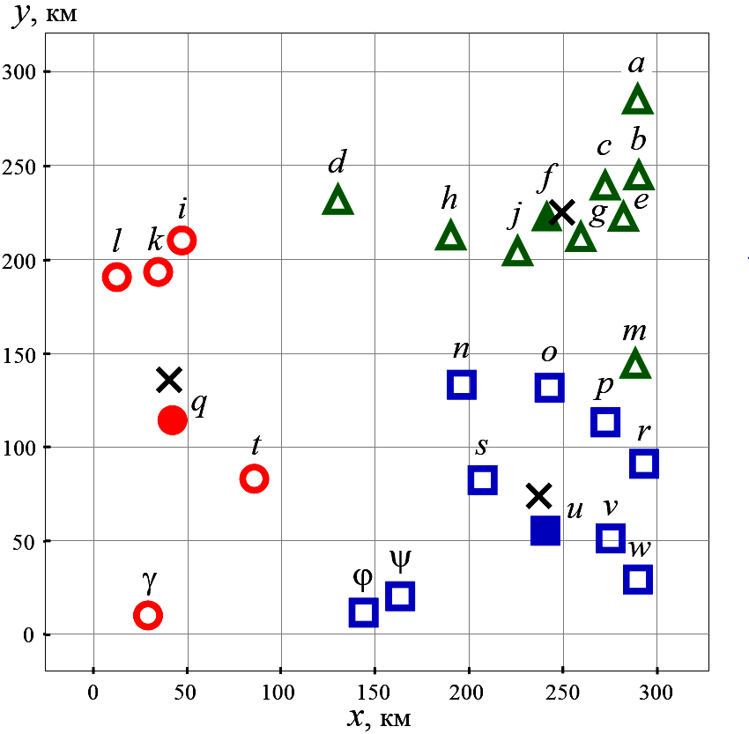
- The result of clusters formation
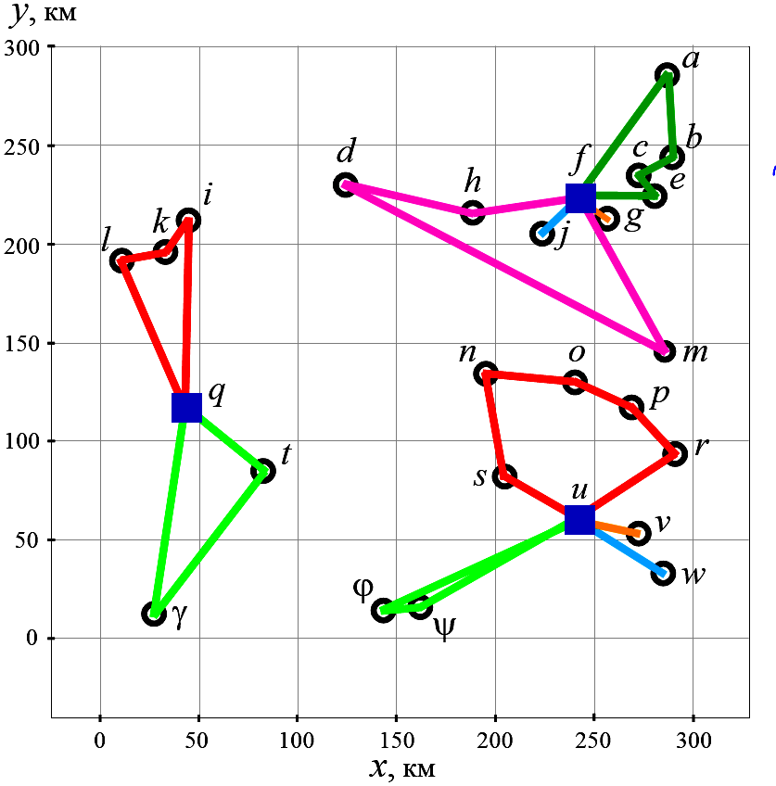
- UAV flight routes

Conclusion
In the paper the problem of optimal transport routing formalized as MTSP with minimizing the maximum length of routes to bypass all cities is considered. The peculiarities of the problem for chances of the only and several depots are discussed. MTSP method of reduction with one depot to the problem of the integer linear programming with eliminating sub-routes by Miller-Taker-Zemlin algorithm is presented. For MTSP solution with several depots two-stage method CFRS (“Cluster First - Route Second”) is used: at the first stage the geospatial clustering of multiple cities is realized, and at the second stage for each cluster one depot is selected and the corresponding MTSP with the only depot is being solved. In this case the iterative algorithmic scheme of space clustering on the basis of K-means method, minimizing total deviation of cluster points from their centers is used. The numerical example of the aviation logistics - the problem of the optimal flight routing of the transport drones is presented.
References
- Caceres-Cruz J., Arias P., Guimarans D., Riera D., Juan A.A. Rich Vehicle Routing Problem: Survey, ACM Computing Surveys, 2015, vol. 47, issue 2, pp. 1-28. DOI: 10.1145/2666003.
- Valeeva A.F., Goncharova Yu.A., Valeev R.S. Routing Tasks During Transportation: an Overview of Models, Methods and Algorithms. Part 1, Logistics and Supply chain Management, 2019, no. 4 (93), pp. 74-89 (in Russian).
- Titov B.A. Transport Logistics: Electron, Textbook. Samara: Samara University Publ., 2012. 198 p. (in Russian).
- Toth P., Vigo D. (eds.). Vehicle Routing: Problems, Methods, and Applications. Philadelphia: Society for Industrial and Applied Mathematics, 2014. 481p. DOI: 10.1137/1.9781611973594.
- Melamed I.I., Sergeev S.I., Sigal I.K. The Traveling Salesman Problem. Issues in Theory, Autom. Remote Control, 1989, vol. 50, no. 9, pp. 1147-1173 (in Russian).
- Dantzig G.B., Ramser J.H. The Truck Dispatching Problem, Management Science, 1959, vol. 6, no. 1, pp. 80-91. DOI: 10.1287/mnsc.6.1.80.
- Clarke G., Wright J.W. Scheduling of Vehicles from a Central Depot to a Number of Delivery Points, Operations research, 1964, vol. 12, no. 4, pp. 568-581.
- The Traveling Salesman Problem and its Variations / Ed. by G. Gutin and A.P. Punnen. NY: Springer, 2007. 850 p.
- Kubil V.N. A Review of the Vehicle Routing Problem Generalizations and Extensions, Vestnik RGUPS, 2018, vol. 70, no. 2, pp. 97-109 (in Russian).
- Filimonov A.B., Filimonov N.B. Optimal Routing by UAV Flights in Group Patrolling of the Territory, Journal of Advanced Research in Technical Science, 2023, issue 34, pp. 49-55 (in Russian). DOI: 10.26160/ 2474-5901-2023-34-49-55.
- Filimonov A.B., Filimonov N.B., Pham Q.P. Planning of Drones Flight of Routes when Group Patrolling of Large Extended Territories, V International Conference on Control in Technical Systems (CTS), Saint Petersburg, 2023, pp. 228-231 (in Russian).
- Filimonov A.B., Filimonov N.B., Nguyen T.K., Pham Q.P. Planning of UAV Flight Routes in the Problems of Group Patrolling of Extended Territories, Mekhatronika, Avtomatizatsiya,Upravlenie, 2023, vol. 24, no. 7, pp. 374-381 (in Russian). DOI: 10.17587/mau.24.374-381.
- Filimonov A.B., Filimonov N.B. The Problem of Group Patrolling of Extended Territories with Multiple Depots, Journal of Advanced Research in Technical Science, 2023, iss. 37, pp. 42-51 (in Russian). DOI: 10.26160/ 2474-5901-2023-37-42-51.
- Filimonov A.B., Filimonov N.B. Planning of UAV Flight Routes During Group Patrolling of Extended Territories, XIV All-Russian Meeting on Control Problems (VSPU-2024), Collection of works, Moscow: IPU RAS, 2024, pp. 1138-1142 (in Russian).
- Filimonov A.B., Filimonov N.B., Nguyen T.K., Pham Q.P. Optimization of UAV Flight Routes During Group Patrolling of Extended Territories as a Multiple Task of a Traveling Salesman with Several Depots, Mekhatronika, Avtomatizatsiya, Upravlenie, 2024, vol. 25, no. 5, pp. 259-265 (in Russian). DOI: 10.17587/mau.25.259-265.
- Cheikhrouhou O., Khoufi I. A Comprehensive Survey on the Multiple Traveling Salesman Problem: Applications, Approaches and Taxonomy, Comput. Sci. Rev, 2021, vol. 40, no. 100369, pp. 76. DOI: 10.1016/j. cosrev.2021.100369.
- Dantzig G.B., Fulkerson D.R., Johnson S.M. Solution of a Large-Scale Traveling Salesman Problem, Operation Research, 1954, vol. 2, pp. 393-410. DOI: 10.1287/opre.2.4.393
- Miller C.E., Tucker A.W., Zemlin R.A. Integer Programming Formulation of Traveling Salesman Problems, Journal of the ACM, 1960, vol. 7, no. 4, pp. 326-329. DOI: 10.1145/321043.321046.
- Şahin Y., Eroğlu A. Metaheuristic Methods for Capacitated Vehicle Routing Problem: Literature Review, Suleyman Demirel University: The Journal of Faculty of Economics and Administrative Sciences, 2014, vol. 19, no. 4, pp. 337-355.
- Labadie N., Prins C., Prodhon C. Metaheuristics for Vehicle Routing Problems. Computer engineering series Computer engineering series. Metaheuristics set (V. 3), John Wiley & Sons, 2016. - 194p. DOI: 10.1002/ 9781119136767.
- Kureichik V.M., Logunova J.A. The Genetic Algorithm Application Prospects Analysis for the Traveling Salesman Problem Solution, Information technologies, 2018, vol. 24, no. 11, pp. 691-697 (in Russian) DOI: 10.17587/it.24.691-697
- Karakatič S., Podgorelec V. A Survey of Genetic Algorithms for Solving Multi Depot Vehicle Routing Problem, Applied Soft Computing, 2015, vol. 27, pp. 519-532. DOI: 10.1016/j.asoc.2014.11.005.
- Liu Y., Li H., Chen H. A Genetic Algorithm for Solving Linear Integer Bilevel Programming Problems, 2018 14th International Conference on Computational Intelligence and Security (CIS), Hangzhou, China, 2018, pp. 40-44. DOI: 10.1109/CIS2018.2018.00017.
- Laporte G., Nobert Y., Arpin D. Optimal Solutions to Capacitated Multi Depot Vehicle Routing Problems, Congressus Numerantium, 1984, vol. 44, pp. 283-292.
- Jain A.K. Data Clustering: 50 years Beyond K-means, Pattern Recognition Letters, 2010, vol. 31, no. 8, pp. 651-666. DOI: 10.1016/j.patrec.2009. 09.011
- Ikotun A.M., Ezugwu A.E., Abualigah L., Abuhaija B., Heming J. K-means Clustering Algorithms: A Comprehensive Review, Variants Analysis, and Advances in the Era of Big Data // ^{i}Information Sciences. 2023. Volume 622, P. 178-210. DOI: 10.1016/j.ins.2022.11.139
- Xu X., Yuan H., Liptrott M. et al. Two Phase Heuristic Algorithm for the Multiple-Travelling Salesman Problem, Soft Comput, 2018, vol. 22, pp. 6567-6581. DOI: 10.1007/s00500-017-2705-5.
- Hasanov I.M., Goltsov I.S. Development of a Two-Phase Cluster Algorithm for Solving the Problem of Transport Routing, Innovation. Science. Education, 2022, no. 50, pp. 2366-2382.
- Gillett B.E., Miller L.R. A Heuristic Algorithm for the Vehicle-Dispatch Problem, Operations Research, 1974, vol. 22, no. 2, pp. 340-349. DOI: 10.1287/opre.22.2.340.
- Bodin L.D. A Taxonomic Structure for Vehicle Routing and Scheduling Problems, Computers &Urban Society, 1975, vol. 1, no. 1, pp.11-29.
- Comert S.E., Yazgan H.R. Effective Cluster-First Route-Second Approaches Using Metaheuristic Algorithms for the Capacitated Vehicle Routing Problem, International Journal of Industrial Engineering: Theory, Applications and Practice, 2021, vol. 28, no. 1, pp. 14-38.
- Beasley J.E. Route First - Cluster Second Methods for Vehicle Routing, Omega, 1983, vol. 11, iss. 4, pp. 403-408. DOI: 10.1016/0305-0483(83) 90033-6.
- Ekiz M.K., Bozdemir M., Türkkan B.Ö. Route First - Cluster Second Method for Personal Service Routing Problem, Journal of Engineering Studies and Research, 2019, vol. 25, no. 2, pp. 18-24. DOI: 10.29081/jesr. v25i2.31.
- Abdirad M., Krishnan K., Gupta D. A Three-Stage Algorithms for the Large-Scale Dynamic Vehicle Routing Problem with Industry 4.0 Approach, Journal of Management Analytics, 2022, vol. 9, no. 3, pp. 313-329. DOI: 10.1080/23270012.2022.2113161.
- Chisman J.A. The Clustered Traveling Salesman Problem // Computers & Operations Research. 1975, no. 2, pp. 115-119. DOI: 10.1016/0305-0548 (75) 90015-5.
- Zhang T., Ramakrishnan R., Livny M. BIRCH: a New Data Clustering Algorithm and its Applications, Data Mining and Knowledge Discovery. 1997, vol. 1, iss. 2, pp. 141-182. DOI: 10.1023/A:1009783824328.
- Murray C.C., Raj R. The Multiple Flying Sidekicks Traveling Salesman Problem: Parcel Delivery with Multiple Drones // Transportation Research Part C: Emerging Technologies. 2020. Vol. 110. P. 368-398. DOI: 10.1016/j.trc.2019.11.003.
- Mashnenkov D.V. Prospects for the Use of UAV in Logistics, Innovation and investment, 2023, no. 6, pp. 168-171 (in Russian).

